Creative Typography: Part 1
Aralee Fajardo >w</

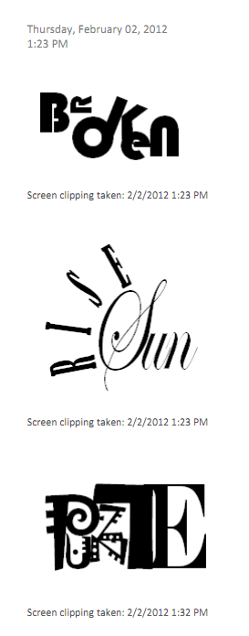
Screen clipping taken: 2/2/2012, 4:02 PM
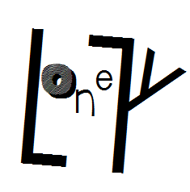
Screen clipping taken: 2/2/2012, 3:31 PM
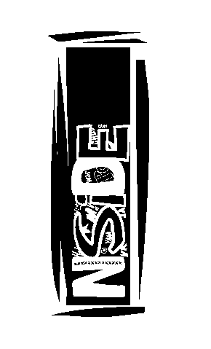
Screen clipping taken: 2/2/2012, 4:19 PM

