Creative Typography: Part 2

Aralee Fajardo >w</

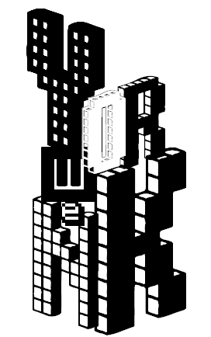

Screen clipping taken: 2/2/2012, 6:37 PM



Screen clipping taken: 2/2/2012, 5:13 PM



Screen clipping taken: 2/2/2012, 7:47 PM



Screen clipping taken: 2/2/2012, 5:46 PM



Screen clipping taken: 2/2/2012, 6:17 PM

Screen clipping taken: 2/2/2012, 8:23 PM