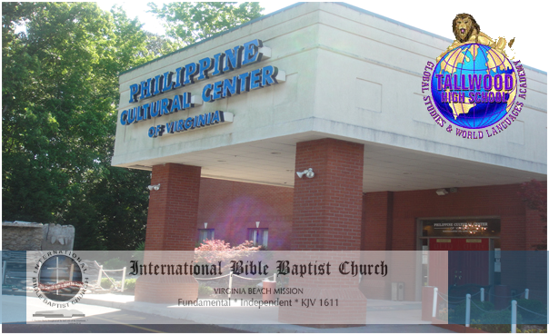
Senior Project Event
Aralee Fajardo
Global Studies and World Languages Academy
Class of 2012

