Marketing Tactics
Student: Aralee Fajardo
Event Place: International Bible Baptist Church
Event Date: April 29th, 2012

- Word - Peer Communication & Family
- Social Networking - Face Book and Twitter
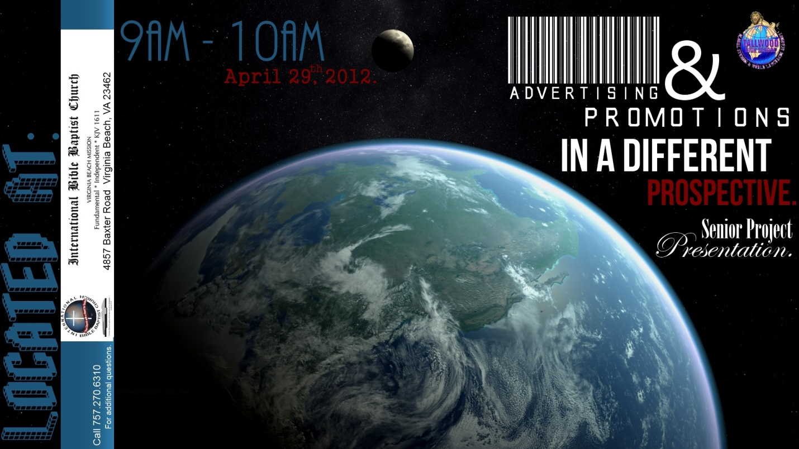
- Flyers

-Disputed during Church
-Placed on community boards in Green Run and Salem areas

